Burvil Eugene Watkins
May 9, 1926 – March 4, 1998

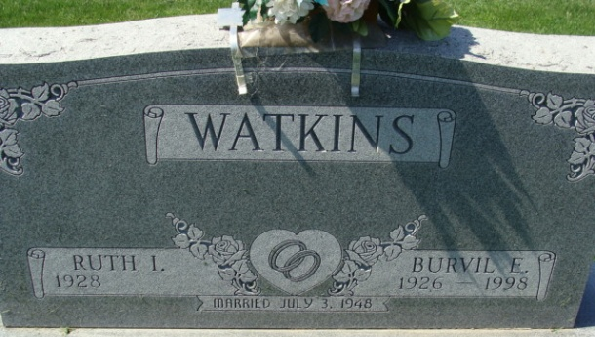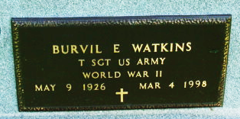
Photo by Alicia Kneuss

Burvil E. Watkins, Decatur, 71, died Wednesday at home. Born in St. Mary’s Township, he retired after 44 1/2 years from Essex Wire in Fort Wayne. He was a World War II Army veteran.
Surviving are his wife, Ruth I.; a daughter, Connie Hockemeyer of Decatur; two brothers, Russell L. of Pleasant Mills and Marvin D. of Decatur; and two grandchildren.
Services at 1:30 p.m. Saturday at Haggard & Sefton Funeral Home, Decatur. Calling from 2 to 5 and 7 to 9 p.m. today. Burial in Decatur Cemetery, with military graveside rites by American Legion Post No. 43.
Memorials to Adams County Home Health Care.

Journal Gazette, Allen County, Indiana
March 6, 1998

**
Decatur Public Library (Adams Co, IN) online obit abstracts

Title: Watkins, Burvil E.
Publication: Decatur Daily Democrat; Date: 05 MAR 1998
Abstract: Age: 71; Died: March 4, 1998; Born: May 9, 1926; Son of: William T. & Bessie M. Durbin Watkins; Married: Ruth I. Herman - July 3, 1948;
Subjects: Obituaries -- W -- 1990-1999

