Paul A. Warthman
February 21, 1922 – November 18, 1965

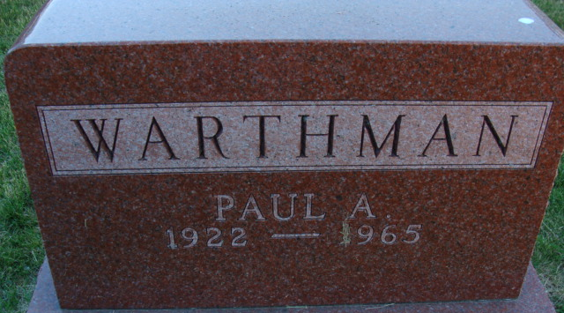
Photo by Alicia Kneuss

Paul A Warthman
in the Indiana, U.S., Death Certificates, 1899-2017
Name Paul A Warthman
Gender Male
Race Caucasian (White)
Marital Status Married
Age 43
Birth Date 21 Feb 1922
Birth Place Indiana
Death Date 18 Nov 1965
Death Place Decatur, Adams, Indiana, USA
Death Registration Date 1965
Father Wilmer Warthman
Mother Anna Yake
Informant Mrs. Paul A Warthman; wife; Decatur, Indiana
Burial November 21, 1965; Oaklawn Cemetery; Ossian, Indiana(sic)

