Zilpha M. (Hebble) Warren
September 22, 1895 – June 13, 1950

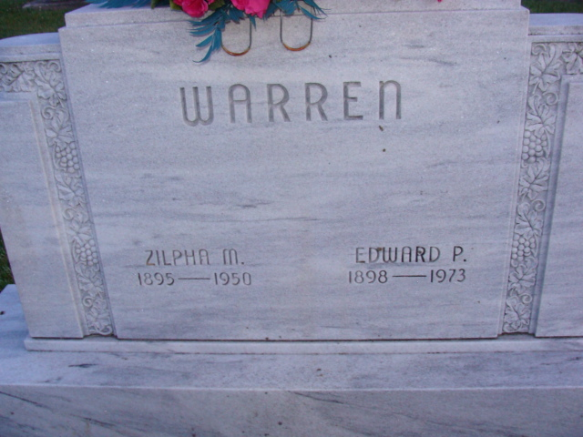
Photo by Alicia Kneuss

Zelphia Warren
in the Indiana, U.S., Death Certificates, 1899-2017
Name Zelphia Warren
[Zelphia Hebble]
Gender Female
Race White
Age 54
Birth Date 22 Sep 1896
Birth Place Indiana
Death Date 13 Jun 1950
Death Place Fort Wayne, Allen, Indiana, USA
Death Registration Date 1950
Father Hezekiah Hebble
Mother Matilda Andrews
Informant Ed Warren; Decatur, Indiana
Burial June 16, 1950; Maplewood Cemetery; Decatur, Indiana

