Richard Warren
March 12, 1918 – March 12, 1918

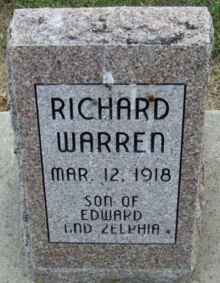
Photo by Alicia Kneuss

Infant Warren
in the Indiana, U.S., Birth Certificates, 1907-1944
Name Infant Warren
Gender Male
Birth Date 12 Mar 1918; stillborn
Birth Place Decatur, Adams, Indiana, USA
Father Edward Warren; age 22
Mother Zilpha Hebble; age 21; 1st child, 0 living
Certificate Number 10862
Roll number 45385_539587
Volume Range 21 - 30

