Edward Plating Warren
April 2, 1898 – March 24, 1973

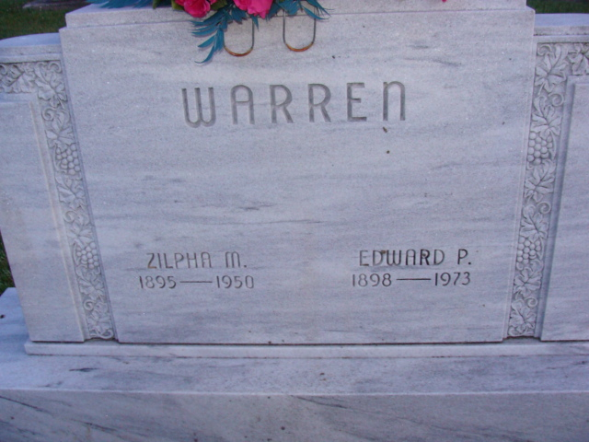
Photo by Alicia Kneuss

Ed Warren, 74, Dies in Florida

Ed Warren, 74, of route 3, died at 10:25 a.m. Saturday at the Lee Memorial Hospital in Fort Myers, Florida. Death was unexpected.
He was a member of the St. Marks’s United Methodist church and Decatur Lodge 571 F & AM.
Mr. Warren was a retired General Electric employee.
He was born in Chicago on April 2, 1898. His wife, Pauline, survives.
Also surviving are two children, Miss Jacqueline Warren of Indianapolis, and one stepdaughter, Mrs. Robert (Kathleen) Ratz of Fort Wayne, four grandchildren and one great-grandchild.
Funeral arrangements are incomplete at the Winteregg-Linn Funeral Home.

Decatur Daily Democrat, Adams County, Indiana
March 26, 1973

**
Rites Planned for Ed Warren
Funeral services for Ed Warren, 74, of route 3, who died Saturday in Fort Myers, Fla., will be held at 10:30 a.m. Thursday at the Winteregg-Linn Funeral Home, with Rev. Fuhrman Miller officiating. Burial will be in the Decatur Cemetery.
Friends may call at the funeral home from 7 to 9 p.m. tonight.
Decatur Daily Democrat, Adams County, Indiana
Wednesday March 28, 1973
**
Florida Death Index, 1877-1998
Name: Edward Plating Warren
Race: White
Age at Death: 74
Birth Date: 2 Apr 1898
Death Date: 24 Mar 1973
Death Place: Lee, Florida, United States

