Glen W. Warner
October 23, 1883 – December 28, 1968

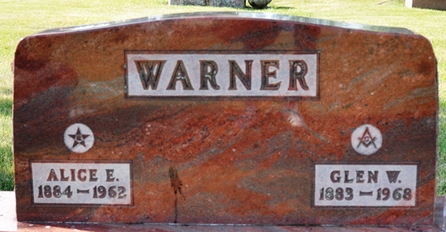
Photo by Deb Curry

Glen W Warner
in the Oregon, U.S., State Deaths, 1864-1971
Name Glen W Warner
Gender Male
Race White
Age 85
Birth Date October 23, 1883
Death Date 28 Dec 1968
Death Place Portland, Multnomah, Oregon, USA
Father Jesse Warner
Mother Alice Ross
Spouse Lucy M
Informant Lucy M. Warner; wife
Removal December 31, 1968; Decatur Cemetery; Decatur, Indiana
Certificate Number 18628

