Alice Edna (Koos) Warner
March 4, 1884 – February 2, 1962

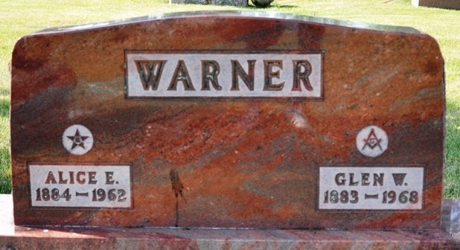
Photo by Deb Curry

Alice Warner Dies after Long Illness
Mrs. Alice Edna Warner, 77, of Lakeville, a native of Adams County, died at 8 a.m. Friday at Elkhart after a year's illness. The daughter of Jacob and Emalie Steele Koos, she was born March 4, 1884 in Adams County. June 2, 1907, she was married to Dr. Glen W. Warner, who survives.
She taught school in Washington Township and for 31 years was secretary to Dr. Warner, when he was editor of School Science and Mathematics Magazine. In 1949 the couple moved from Chicago, Ill.., to Lakeville. Dr. Warner taught at the city college in Chicago.
She was a member of the Lakeville Order of the Eastern Star Chapter 479, and the Methodist Church.
One son, Lowell C. Warner, of Lincolnwood, Ill., one grandchild, and two great-grandchildren survive, in addition to a sister, Mrs. Claude (Essie) Harvey, of Monroe. Mrs. Harvey (Gladys) Koos are sisters-in-law.
Friends may call at the Brink Funeral Home, Lakeville, after 7 p.m. today. Services will be held here at 10 a.m. (CST) Monday. Services will be held in Decatur at the Zwick Funeral Home at 3:30 a.m. Monday, the Rev. Samuel Phillips, of Lakeville Methodist Church, officiating. Burial will be in the Decatur Cemetery.
Adams County Historical Museum, Adams County, Indiana
January 1951 – August 1962 Scrapbook
Handwritten date: Saturday, February 3, 1962

