Frederick W. Warfel
July 12, 1927 – July 14, 1989

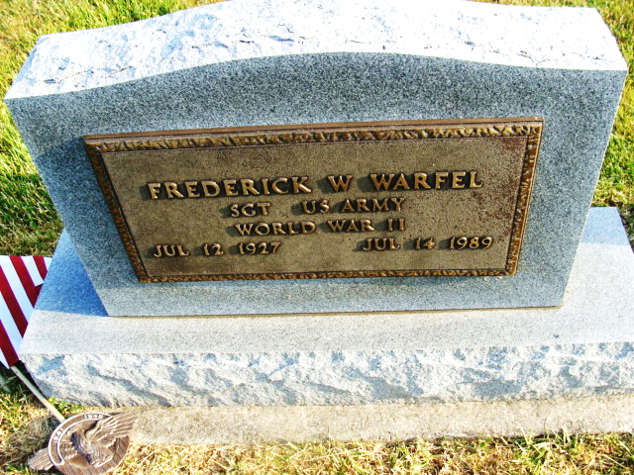
Photo by Alicia Kneuss

Frederick W Warfel
in the Indiana, U.S., Death Certificates, 1899-2017
Name Frederick W Warfel
Gender Male
Race White
Marital Status Married
Age 62
Birth Date 12 Jul 1927
Birth Place Huntington County, Indiana
Death Date 14 Jul 1989
Death Place Decatur, Adams, Indiana, USA
Death Registration Date 1989
Father Howard Warfel
Mother Edith Pratt
Spouse Joanna Daily
Informant Joanna Warfel; wife; Berne, Indiana
Burial July 17, 1989; Decatur Cemetery; Decatur, Indiana

