Norman Paul Ward
March 31, 1933 – June 8, 2011

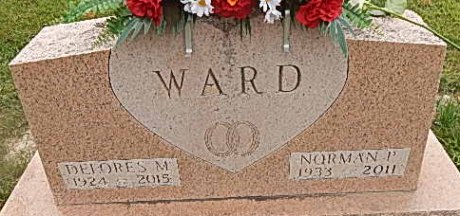
Photo by Alicia Kneuss

Norman Ward, 78, of Decatur, passed away on Wednesday, June 8, 2011, at his residence. He was born in Decatur to Harley H. and Amanda E. (Neuenschwander) Ward on March 31, 1933. On May 20, 1951, he married Delores Ginter.
Norman is survived by his wife of 60 years, Delores Ward of Decatur; two sons, Kenneth G. (Corazon) Ward of Decatur and Keith L. (Brenda) Ward of Wren, Ohio; two daughters, N. Gayle Ward of Fort Wayne and Kendra (Alan) Beard of Convoy, Ohio; a sister, Joyce (Harry) Moser of Wren; five grandchildren; and nine great-grandchildren. He was preceded in death by a twin sister, Norma P. Ward; two other sisters, June Diehl and Elvira Habeggar; and a brother, Rev. Roger H. Ward.
Norm attended Decatur Church of God, where he served as an usher for 15 years. He retired in 1995 from Chrysler Corporation as a tool and die maker.
Visitation will be held on Friday, June 10, 2011, from 2-4 and 6-8 p.m. at Haggard-Sefton and Hirschy Funeral Home in Decatur. Funeral services will be on Saturday, June 11, 2011, at 10 a.m. in Decatur Church of God. Dr. Robert Brink will officiate. Burial will be in Decatur Cemetery. Memorials may be given to Decatur Church of God or to Family Hospice and Palliative Care of Northeast Indiana, at Berne.

Decatur Daily Democrat, Adams County, Indiana
June 9, 2011

