James Edward Ward
March 15, 1868 – August 24, 1945

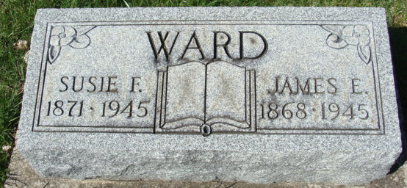
Photo by Alicia Kneuss

James Edward Ward
in the Indiana, Death Certificates, 1899-2011
Name: James Edward Ward
Gender: Male
Race: White
Age: 76
Marital status: Married
Birth Date: 15 Mar 1869 (sic)
Birth Place: Wells County
Death Date: 24 Aug 1945
Death Place: Ft Wayne, Allen, Indiana, USA
Father: James Henry Ward
Mother: Mary Francis
Informant: Harley Ward
Burial: August 27, 1945; Decatur Cemetery; Decatur, Indiana

