Harvey Benjamin Ward
March 10, 1896 – December 5, 1924

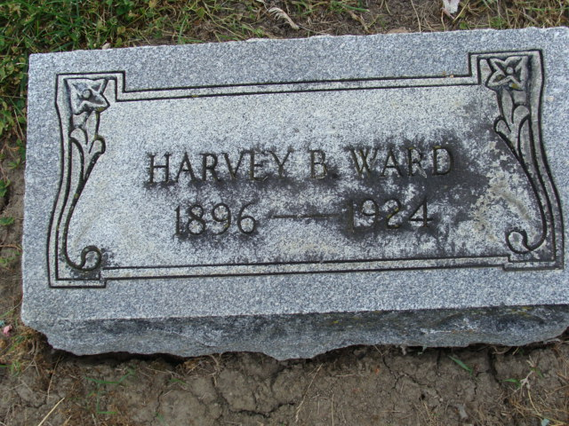
Photo by Alicia Kneuss

Harney Benginan Ward
in the Indiana, Death Certificates, 1899-2011
Name: Harvey Bengiman Ward
Gender: Male
Race: White
Age: 28
Marital status: Married
Birth Date: 10 Mar 1896
Birth Place: Indiana
Death Date: 5 Dec 1924
Death Place: Decatur, Adams, Indiana, USA
Father: James Ward
Mother: Susie Drum
Spouse: Cleo Elizabeth
Informant: Cleo E. Ward; Decatur, Indiana
Burial: December 7, 1924; Decatur Cemetery

