Esther N. (Stevens) Ward
August 23, 1909 – December 27, 1972

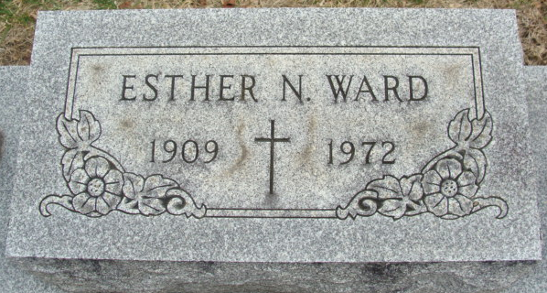
Photo by Alicia Kneuss

Esther N. Ward Dies this Morning

Mrs. Esther N. Ward, 63, wife of Charley P. Ward of Decatur route 5, died suddenly at 3:55 a.m. today at the Adams county memorial hospital.
A lifelong resident of Adams County, she was born to John N. and Sylvia Chronister-Stevens Aug. 23, 1909, and was married to Charley P. Ward Dec. 5, 1927. She retired from Bag Service in 1966.
Mrs. Ward was a member of Nuttman Ave. United Brethren Church.
Surviving are her husband; two daughters, Mrs. Helen Johnson, wife of Raymond (Bing) Johnson of Decatur and Miss Catherine C. Ward, at home; one son, Charley Ward, Jr. of Bluffton; two sisters, Mrs. Dorothy Bowman of Decatur route 3, and Mrs. Doyle (Ruth) Gilbert of Monroe route 1; one brother, Dale Smitley of Huntington; six grandchildren; and two great-grandchildren.
Funeral services will be conducted at 1:30 p.m. Friday at the Winteregg-Linn Funeral Home, with Rev. Sylvester Martin officiating. Burial will be in the Decatur Cemetery. Friends may call at the funeral home after 2 p.m. Thursday until time of the services.

Decatur Daily Democrat, Adams County, Indiana
Wednesday, December 27, 1972
**

Indiana, Death Certificates, 1899-2011
Name: Esther N Ward
[Esther N Stevens]
Gender: Female
Race: White
Age: 63
Marital status: Married
Birth Date: 23 Aug 1909
Birth Place: Ind
Death Date: 27 Dec 1972
Death Place: Decatur, Adams, Indiana , USA
Father: John N Stevens
Mother: Silvia Chronister
Spouse: Charley P Ward
Informant: Charley P. Ward; husband; Decatur, Indiana
Burial: December 29, 1972; Decatur Cemetery; Decatur, Indiana

