Delores May (Ginter) Ward
January 14, 1924 – June 20, 2015

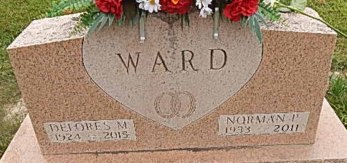
Photo by Alicia Kneuss

Delores M. Ward, 91, of Decatur, IN died June 20, 2015 at Adams Woodcrest. Delores was born in Adams County, IN to the late Homer C. and Aldine (Klopfenstein) Ginter. On May 20, 1951 she married Norman P. Ward; he preceded her in death on June 8, 2011. Delores was a member of the Decatur Church of God, where for many years she enjoyed photographing her church family and friends. She was also active in the “Happy Huggers” women’s group.
Dee will be fondly remembered as a loving mother and grandmot-her, who was a wonderful cook and pie baker. Some of her proudest moments were participating and winning blue ribbons at the Indiana State Fair Pie Baking Competition. She retired in 1981 from General Electric in Fort Wayne.
She is survived by her children, N. Gayle Ward of Decatur, IN, Kenneth G. (Corazon) Ward of Decatur, IN, Keith L. (Brenda) Ward of Wren, OH and Kendra (Alan) Beard of Convoy, OH; 4 grandchildren, Misty (Greg) Bruns, Jason (Sarah) Ward, Ashley Marks and Jared (Ashley) Beard and 10 great grandchildren. Delores was preceded in death by 5 brothers and 4 sisters.
Visitation will be from 4:00-8:00 p.m. Wednesday, June 24, 2015 at Haggard-Sefton & Hirschy Funeral Home. Funeral service will be at 11:00 a.m. on Thursday, June 25, 2015 at Decatur Church of God. Dr. Robert Brink will be officiating. Burial will be in Decatur Cemetery.
Memorials are to Decatur Church of God.

Haggard-Sefton Funeral Home, Adams County, Indiana
June 21, 2015

**
Indiana, Birth Certificates, 1907-1940
Name: Dolores May Ginter
Gender: Female
Birth Date: 14 Jan 1924
Birth Place: Kirkland, Adams, Indiana, USA
Registration Year: 1924
Father: Homer Ginter
Mother: Aldine Kloffenstein
Certificate Number: 33
Roll Number: 001
Agency: Indiana State Board of Health
Volume Range: 1 - 5

