Charley P. Ward
1906 – June 6, 1978

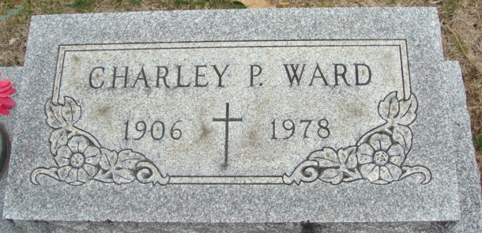
Photo by Alicia Kneuss

Charley P Ward
in the Indiana, Death Certificates, 1899-2011
Name: Charley P Ward
Gender: Male
Race: White
Age: 72
Marital status: Widowed
Birth Date: abt 1906
Birth Place: Ind.
Death Date: 8 Jun 1978
Death Place: Decatur, Adams, Indiana, USA
Father: James E Ward
Mother: Susie Drum
Informant: Miss Catherine C. Ward; Decatur, Indiana
Burial: June 12, 1978; Decatur Cemetery; Decatur, Indiana

