Catherine C. Ward
October 11, 1931 – July 25, 2011

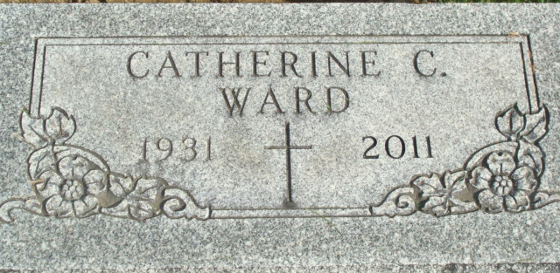
Photo by Alicia Kneuss

Catherine C. “Katie” Ward, 79 of Decatur died on Monday, July 25, 2011 at Adams Memorial Hospital. She was born in Adams County, Indiana to the late Charley P. and Esther N. (Stevens) Ward. Katie attended Woodcrest chapel service and retired in 1980 from General Electric after 25 years of service. She was a member of the G.E. Quarter Century Club, retired Ladies of G.E., former member of the Adams County Heart Association and Adams County Diabetes Association.
She is survived by three nieces Linda Springer of Decatur, Sandy Jones of Pittsburg, PA and Teresa Simon of Decatur; and several great nieces and nephews. She is preceded in death by a brother Charley J. Ward and a sister Helen M. Johnson.
Visitation will be from 4:00-8:00 p.m. Thursday, July 28, 2011 at Haggard-Sefton and Hirschy Funeral Home. Funeral service will be at 10:00 a.m. Friday, July 29, 2011 also at the funeral home. Pastor Ken Hogg will be officiating and burial will be in Decatur Cemetery. Memorials are to Adams County Heart Association.

Haggard & Sefton Funeral Home, Adams County, Indiana
July 26, 2011

**
Indiana, Death Certificates, 1899-2011
Name: Catherine C Ward
Gender: Female; Race: White; Age: 79
Marital status: Never Married (Single)
Birth Date: 11 Oct 1931, Birth Place: Adams County, IN
Death Date: 25 Jul 2011, Death Place: Decatur, Adams, Indiana, USA
Father: Charley P Ward
Mother: Esther N Stevens
Informant: Craig Simon; nephew; Bluffton, Indiana
Burial: Decatur Cemetery; Decatur, Indiana

