Danielle (Salwolke) Wampler
March 15, 1975 – May 14, 2017

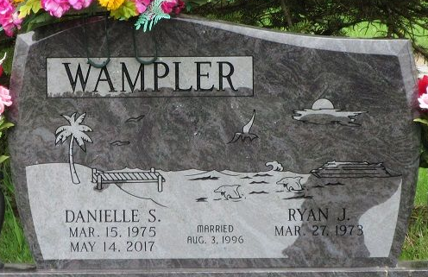
Photo by PLS

Danielle S. Wampler, 42 years old of Decatur, Indiana, passed away on Sunday, May 14, 2017 at Adams Memorial Hospital Emergency Room. She was born on Saturday, March 15, 1975 in Iron Mountain, Michigan the daughter of Pat and Marlene "Kay" (Sherlund) Salwolke. She married Ryan J. Wampler on August 3, 1996 in Warsaw, Indiana.
Danielle attended the Decatur Church of God. She was a Green Bay Packer fan and she loved to read. She loved to travel, especially cruises and spending time on the beach. Danielle also loved spending time at the lake and having her friends over. She was a graduate of Warsaw High School in 1993 and she received a criminal justice degree from IPFW in Fort Wayne. She was employed at CenturyLink in Decatur since September 2002.
Surviving are her husband, Ryan J. Wampler of Decatur, IN; two children, Sarah & Seth Wampler at home; parents, Pat & Kay Salwolke of Leesburg, IN; in-laws, Brenda & Todd Shuherk of Warsaw, IN; and Steve & Sylvia Wampler of Ozark, MO.
Funeral services will be held at 2:00 p.m. Thursday, May 18, 2017 at Decatur Church of God with Rev. Dr. Robert Brink officiating. Interment will follow in the Decatur Cemetery. Friends will be received from 2 to 5 and 6 to 8 p.m., Wednesday, May 17 in the Zwick & Jahn Funeral Home in Decatur and one hour prior to the service at the church on Thursday.
Preferred memorials are to the Children's Education Fund.

Zwick & Jahn Funeral Home, Adams County, Indiana
May 17, 2017

