Rollin A. Waltz
September 25, 1892 – June 4, 1959

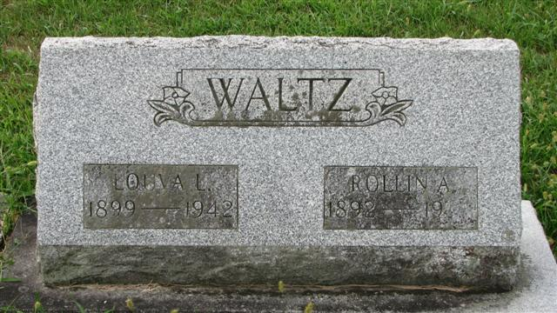
Photo by Alicia Kneuss

Rollin A Waltz
in the Texas, Death Certificates, 1903-1982
Name: Rollin A Waltz
Gender: Male
Race: White
Age: 66
Birth Date: 25 Sep 1892
Birth Place: Massachusetts
Residence: Houston, Harris, Texas, USA
Death Date: 4 Jun 1959
Death Place: Houston, Harris, Texas, USA
Father: Alonzo Waltz
Informant: Mrs. Caron Waltz
Removal: June 6, 1959; Tulsa, Oklahoma

**Note**
Cenotaph – buried in Memorial Park Cemetery in Oklahoma

