Louva La Faun (Stoneburner) Waltz
April 18, 1899 – May 9, 1942

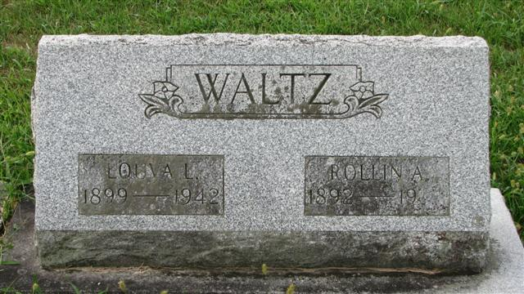
Photo by Alicia Kneuss

Louva La Faun Waltz
in the Indiana, Death Certificates, 1899-2011
Name: Louva La Faun Waltz
[Louva La Faun Stoneburner]
Gender: Female
Race: White
Age: 43 years, 0 months, 21 days
Marital status: Married
Birth Date: abt 1899
Birth Place: Adams Co Ind
Death Date: 9 May 1942
Death Place: Monroe, Adams, Indiana, USA
Father: John Stoneburner
Mother: Mary E Barnett
Spouse: Rollan Waltz
Informant: Rollan Waltz; Tulsa, Oklahoma
Burial: May 11, 1942; Decatur Cemetery; Decatur, Indiana

