Margaret M. (Thatcher) Waltke-Scharra
May 17, 1898 – September 22, 1972

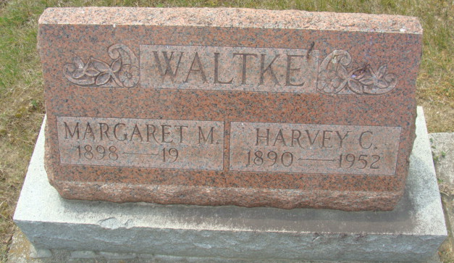
Photo by Alicia Kneuss

SERVICES HELD FOR MRS. SCHARRA

Funeral services were held Tuesday in Fort Lauderdale, Fla., for Mrs. Margaret Waltke Scharra, 74, a former resident of Bobo, who died Sept. 22 in Fort Lauderdale. Mrs. Scharra was a member of the Peace United Presbyterian Church, the Eastern Star and Senior Citizen's Club. She retired several years ago from the Decatur General Electric plant and was a member of the Ge Code Club. She was born in Adams County, the daughter of John and Mary Jane Troutner - Thatcher, and was married to Otto Scharra.
Survivors include the husband, one son, Johnny of Bloomington, and two grandchildren. Mrs. Scharra had a number of relatives in Adams County. One daughter preceded her in death.

Unknown source
September 26, 1972

**
Florida Death Index, 1877-1998
Name: Margaret Scharra
Death Date: 22 Sep 1972
County of Death: Browa
State of Death: Florida
Age at Death: 74
Race: White
Birth Date: 17 May 1898

This is a cenotaph - she is buried in Florida.

