Harvey Christian Waltke
June 14, 1900 – June 18, 1952

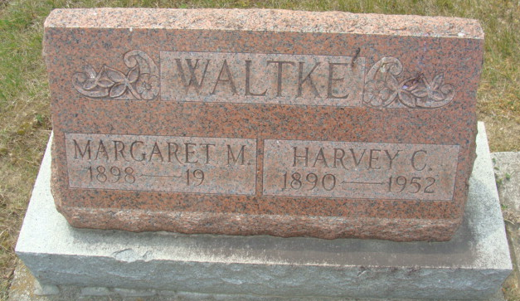
Photo by Alicia Kneuss

Harvey C. Waltke Is Taken By Death
Funeral Services Saturday Afternoon

Harvey Christian Waltke, 52, of Bobo, died at 5:06 o'clock Wednesday evening at the Adams County Memorial Hospital following a year's illness of complications. He was born in Fort Wayne June 14, 1900, a son of George and Harriett Davis-Waltke, and was married to Margaret Thatcher Sept. 20, 1922.
Surviving in addition to his wife, are a son, Johnnie G. Waltke of Bedford, and two grandchildren. One brother and one sister preceded him in death.
Funeral services will be held at 1:30 p.m. Saturday at the Black Funeral Home, and at 2 o'clock at the Bobo United Brethren Church, the Rev. William Ensminger officiating. Burial will be in the Decatur Cemetery. Friends may call at the funeral home after 7 o'clock this evening.

Decatur Daily Democrat, Adams County, Indiana
June 19, 1952

**
Indiana, Death Certificates, 1899-2011
Name: Harvey Christian Waltke
Gender: Male
Race: White
Age: 52
Marital status: Married
Birth Date: 14 Jun 1900
Birth Place: Ft Wayne, Indiana
Death Date: 18 Jun 1952
Death Place: Decatur, Adams, Indiana , USA
Father: George Waltke
Mother: Harriet Davis
Informant: Mrs. Harvey Waltke; Bobo, Indiana
Burial: June 21, 1952; Maplewood Cemetery; Decatur, Indiana

