Mary C. (Pieper) Walther
October 28, 1868 – March 27, 1957

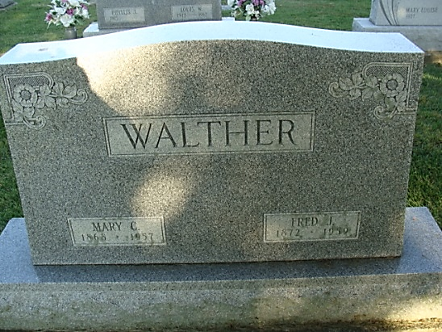
Photo by Alicia Kneuss

Mrs. Mary Walther Is Taken By Death
Funeral Services Saturday Afternoon

Mrs. Mary C. Walther, 88, died at 3:15 p.m. Wednesday at her home, 931 North Fifth Street, following an illness of three months. She was born in Hamilton, O., Oct. 28, 1868, a daughter of Mr. and Mrs. Lambert Pieper, and was married to Fred J. Walther Nov. 24, 1892. The family has lived in Decatur since 1929.
Surviving in addition to her husband are a daughter, Mrs. Harry G. Young, Decatur; a son, Robert Walther of Hamilton, O., two grandchildren, Clarence Walther of Miami, 0., and Mrs. Herbert Braun of Michigan City, and five great-grandchildren.
Funeral services will be conducted at 1:30 p.m. Saturday at the Zwick Funeral Home, the Rev. Ray J. Walther officiating. Burial will be in the Decatur Cemetery. Friends may call at the funeral home after 7 o'clock this evening until time of the services.

Decatur Daily Democrat, Adams County, Indiana
Thursday, March 28, 1957
**

Indiana, U.S., Death Certificates, 1899-2017
Name: Mary C. Walther
[Mary C. Pieper]
Gender: Female
Race: White
Age: 88
Marital Status: Married
Birth Date: 28 Oct 1868
Birth Place: Ohio
Death Date: 27 Mar 1957
Death Place: Decatur, Adams, Indiana, USA
Father: Lambert Pieper
Burial: March 30, 1957 Decatur Cem.

