Jerry Leon Walther
May 19, 1938 – October 18, 1941

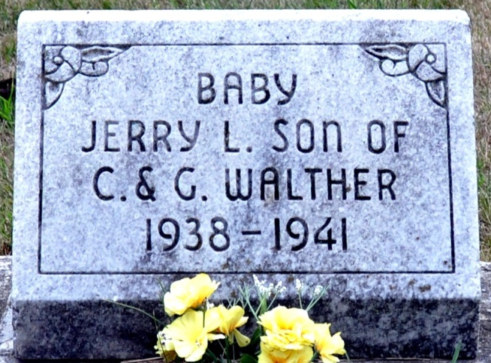
Photo by Deb Curry

Jerry Leon Walther
in the Indiana, Death Certificates, 1899-2011
Name: Jerry Leon Walther
Gender: Male
Race: White
Age: 3
Marital Status: Single
Birth Date: 19 May 1938
Birth Place: Decatur Ind
Death Date: 18 Oct 1941
Death Place: Ft Wayne, Allen, Indiana, USA
Father: Clarence Walther
Mother: Glady Walther
Burial: Oct. 21, 1941 Decatur Cem

