Frederick J. Walther
September 17, 1872 – November 27, 1959

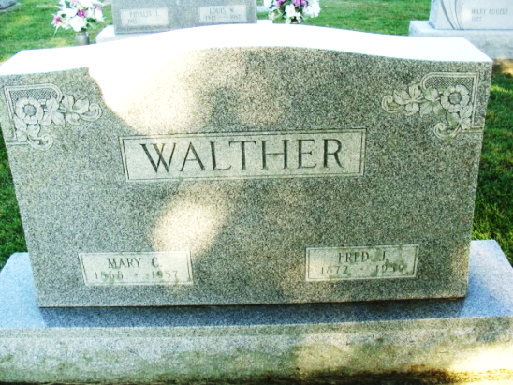
Photo by Alicia Kneuss

Frederick J. Walther
in the Indiana, Death Certificates, 1899-2011
Name: Frederick J. Walther
Gender: Male
Race: White
Age: 87
Marital Status: Widowed
Birth Date: 17 Sep 1892 (sic)
Birth Place: Ohio
Death Date: 27 Nov 1959
Death Place: Decatur, Adams, Indiana, USA
Father: Frederick Walther
Mother: Christine
Informant: Mrs. Harry Young, daughter
Burial: Nov. 30, 1959 Decatur Cem., Decatur, Indiana

