William D. Walters
April 9, 1880 – January 26, 1912

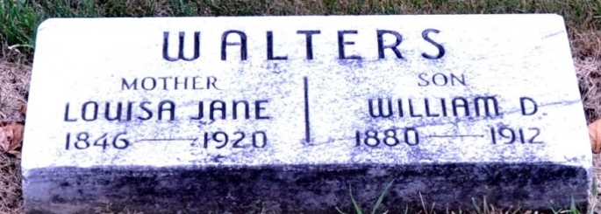
Photo by Deb Curry

WITHOUT WARNING
Death Came Unexpectedly to William Walters at 8:15 This Morning - HAD BEEN ILL LONG
But Was Not Bedfast - Was Son of Mr. and Mrs. John Walters

Although he had been ailing the past seventeen months or more with lung trouble and asthma, death came most unexpectedly at 8:15 this morning to William Walters, a well-known young man of this city. Mr. Walters had been in poor health for many months, but had, at times, been able to walk about though the greater part of the past year he had been confined to the house. At no time was he bedfast, and this morning had been sitting up, as usual. At about 8:15 he stated that he desired no breakfast, and had been prevailed upon by Mrs. Walters to lie down a while. He lay down on the bed and Mrs. Walters left the room for just a little while to get something and when she returned a few moments afterward, he had breathed his last. For the past week or so, the asthma had been particularly bad, but he seemed no worse in particular this morning than at other times, and his death at this time was most unexpected.
The deceased was born on a farm east of the city, thirty-one years ago last April 9th. He was the son of John and Louisa Walters and the first eleven or twelve years of his life were spent in this county and city. The family then went to Fairmount and Mr. Walters had resided at various cities in his young manhood, his occupation being that of train dispatcher. He was married December 2, 1900, to Miss May White, at LaFontaine, and their married life had been a particularly happy one. Prior to coming here about a year ago they resided at Garrett, where Mr. Walters was train dispatcher for the B & O Railroad.
Mr. Walters leaves, besides his bereaved wife, one daughter, Corrine. His father died several years ago, but his mother is still living, residing at the Daniel Shackley home. He also leaves three brothers - Hiram, at LaFontaine; Nelson, at Anderson, and Frank at Marion. Mr. Walters was a young man of many noble qualities, and the cutting off of a life just in its prime, is a thing sadly deplored. Mr. Walters was a social member of the local Yeomen order.
The funeral will be held Sunday afternoon at 2:30 o'clock at the Methodist church.

Decatur Daily Democrat, Adams County, Indiana
Friday, January 26, 1912
**
Indiana, Death Certificates, 1899-2011
Name: William D Walters
Gender: Male
Race: White
Age: 31
Marital status: Married
Birth Date: 9 Apr 1880
Birth Place: Adams Co., Ind
Death Date: 26 Jan 1912
Death Place: Decatur, Adams, Indiana , USA
Father: John Walters
Mother: Louisa Shackley
Spouse: May
Informant: May Walters; Decatur, Indiana
Burial: January 28, 1912; Decatur Cemetery

