Samantha Rachel (Venis) Walters
1873 – December 7, 1954

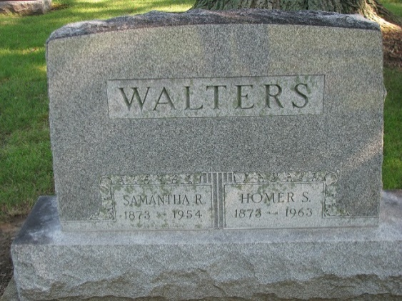
Photo by PLS

Mrs. Homer Walters is taken by Death
Heart Attack Fatal to Former Resident

Mrs. Homer Walters, 81, a former resident of Decatur, died Tuesday night at her home in Defiance, O, following a heart attack. She was the former Rachel Samantha Venis of this city before her marriage.
Survivors include two sons, Don L. and Burt Walters of Defiance; two daughters, Mrs. William Moore of Wyandotte, Mich., and Mrs. Helen Bott of Defiance; 10 grandchildren and eight great-grandchildren. There are a number of relatives in Decatur and vicinity.
Funeral services will be held at 10 o'clock Friday morning at the Mansfield mortuary in Defiance, with the Rev. Bollinger officiating. The body will be brought to the Decatur Cemetery for graveside services about 2 p.m. Friday.

Decatur Daily Democrat, Adams County, Indiana
December 9, 1954

