Rosa L. (Nelson) Walters
May 31, 1875 – January 30, 1902

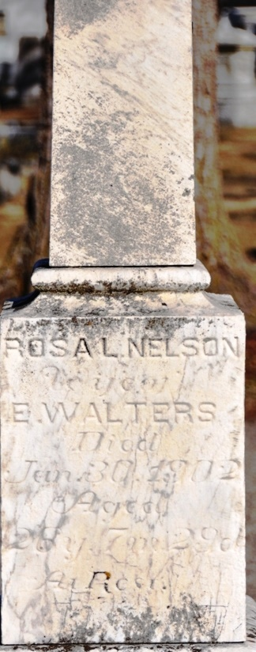
Photo by Deb Curry

Mrs. Emery Walters died at an early hour Thursday morning after a week’s illness. She was a popular young woman, kind and lovable and her death is deeply mourned by all who knew her.
A devoted husband and a little daughter with many other relatives and friends remain to mourn their sad loss.
Rev. E. H. Pontius conducted the funeral services from the United Brethren Church Saturday afternoon. Interment at Maplewood.

Decatur Democrat; Adams County, Indiana
A weekly newspaper
Thursday, February 6, 1902

**
Rosa Lorena Nelson, daughter of Levi and Ruth Nelson, was born in DeKalb Co., Ind., May 31, 1875, and died in Decatur, Ind., January 30, 1902, aged 26 years, 7 months and 29 days. When a girl she came with her parents to Adams County, where she spent the remainder of her life.
She became a member of the United Brethren Church during the revival services conducted during the winter of 1890. She was united in marriage to Emery Walters, March 8, 1900, with whom a short but happy life was spent.
All was done for her that loving hands and medical skill could do, but to no avail. She called her relatives and friends to her bedside and admonished them to meet her in Heaven.
An affectionate husband and small son, besides a father, four brothers, two sisters and a host of friends survive her.
May God bless them and keep them in their dark hours which enrapse the departure of a loving wife and an affectionate sister.

Decatur Democrat; Adams County, Indiana
A weekly newspaper
Thursday, February 20, 1902

**
Indiana, U.S., Death Certificates, 1899-2011
Name: Rosa L Walters
[Rosa L Nellson]
Gender: Female
Race: White
Age: 26 years, 7 months, 29 days
Marital status: Married
Birth Date: 31 May
[abt 1876]
Birth Place: Indiana
Death Date: 30 Jan 1902
Death Place: Decatur, Adams, Indiana, USA
Father: Levi Nellson
Mother: Ruth Taylor
Spouse: Emery D Walters
Informant: Emery Walters; Decatur, Indiana
Burial: February 1, 1902; Maplewood Cemetery

