Orley B. Walters
January 22, 1909 – February 18, 1973

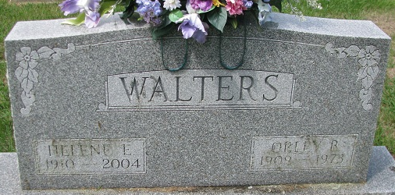
Photo by PLS

Orley B. Walters Dies at Hospital
Orley B. Walters, 64, of 1310 Mix Ave., employed at the Automatic Sprinkler in Monroe for the past 10 years, died at 4:55 p.m. Sunday at the Adams County Memorial Hospital. He had been hospitalized since Dec. 11. Mr. Walters was a member of the Zion Lutheran Church.
He was born in Union Township on Jan. 22, 1909, the son of Freeman and Belle Barkley-Walters, and was married to Helene Berning on Dec. 30, 1933.
Surviving are the wife; seven children, Donald Walters of Fort Wayne; Mrs. Ferris (Barbara) Kohne of route 4; Mrs. Nolan (Lorraine) Griffiths of route 2; Mrs. Lester (Pamela) Smith of route 2; Mrs. Dennis (Kathleen) Fenker of route 2, Columbia City; Mrs. James M. (Joanne) Wetzel of route 1; and Charles F. Walters, at home; four sisters, Mrs. Kenneth (Genevieve) Parrish of route 1, Monroe; Mrs. Elmo (Naomi) Stuckey of Monroe; Mrs. Wilson (Anoli) Mann of Monroe; Mrs. Richard (Phyllis) Everett of Monroe; and 17 grandchildren.
Funeral services will be held at 1:30 p.m. Wednesday at the Zwick Funeral Home, with Rev. Richard C. Ludwig officiating. Burial will be in the Decatur Cemetery. Friends may call at the funeral home after 7 p.m. tonight. Preferred memorials are to the Zion Building Fund or the American Cancer Society.

Decatur Daily Democrat, Adams Co, Indiana
Monday, February 19, 1973

