Oliver C. Walters
January 22, 1874 – February 9, 1962

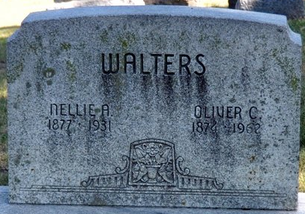
Photo by Deb Curry

Final Rites Monday for Oliver Walters

Funeral services will be held Monday afternoon for Oliver Walters, 88, lifelong resident of Union Township, who died at 12:55 p.m. Friday at the Adams County Memorial Hospital. He had been ill for five years of complications. He was born in Union Township Jan. 22, 1874, a son of Henderson and Emaly Walters, and was married to Nellie Cramer March 4, 1897. His wife preceded him in death in 1936. Mr. Walters was a member of the Union Chapel Evangelical United Brethren Church.
Surviving are two sons, Forest and John Walters, both of Decatur; three grandchildren; four great-grandchildren; one brother, Freeman Walters of Monroe, and a stepbrother, Homer Walters of Continental, O. Two brothers and one sister are deceased.
Services will be conducted at 2 p.m. Monday at the Black Funeral Home, the Rev. Kenneth Angle officiating. Burial will be in the Decatur Cemetery. Friends may call at the funeral home after 7 p.m. today until time of the services.

Decatur Daily Democrat, Adams County, Indiana
February 10, 1962

