Nellie Alice (Cramer) Walters
January 9, 1877 – January 17, 1931

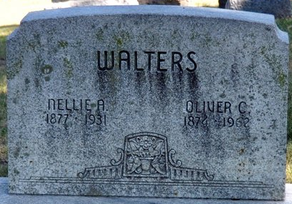
Photo by Deb Curry

Nellie Alice Walters
in the Indiana, Death Certificates, 1899-2011
Name: Nellie Alice Walters
[Nellie Alice Craner]
Gender: Female
Race: White
Age: 54
Marital status: Married
Birth Date: 9 Jan 1877
Birth Place: Indiana
Death Date: 17 Jan 1931
Death Place: Decatur, Adams, Indiana, USA
Father: John Craner
Mother: Carline Helm
Spouse: Oliver Walters
Informant: Oliver Walters; Decatur, Indiana
Burial: January 19, 1931; Decatur Cemetery

