Marjorie Irene (Bieberich) Walters
April 10, 1926 – December 30, 2008

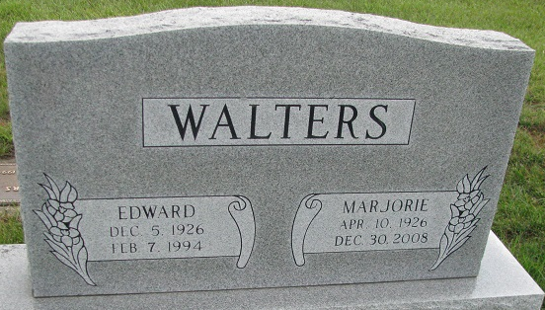
Photo by PLS

Marjorie Irene Walters, 82, of Maben, Mississippi formerly of Decatur, passes away December 30, 2008 in Maben, MS, where she resided for 55 years. She was born April 10, 1926 in Decatur, Indiana to the late Lorance D. & Naomie F. (Arnold) Bieberich. She married Edward Lorance Walters on December 10, 1944 and he’s deceased.
She is survived by 3 sons Roland L. (Donna) Walters of Selma, WI, Richard B. (Nancy) Walters of Maben, MS and Randolph O. (Maria) Walters of Biloxi, MS; a sister Helen Conrad of Decatur; a brother Roy Bieberich of Decatur, two grandchildren and one great grandchild. She is preceded in death by a three sisters, Virgene I. Bowers, Marie & Evelyn Bieberich.
Funeral services will be held Monday, January 5, 2009 at 2:00 pm at Haggard & Sefton Funeral Home with visitation 1 hour prior to services. Burial will be in Decatur Cemetery. Memorials are to Donor’s Choice.

Haggard & Sefton Funeral Home, Adams County, Indiana
December 31, 2008

