Marion E. Walters
1909 - 1910

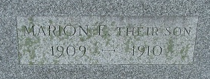
Photo by PLS

No further information found at this time

