Margaret J. (Teeple) Walters
March 24, 1849 – January 21, 1934

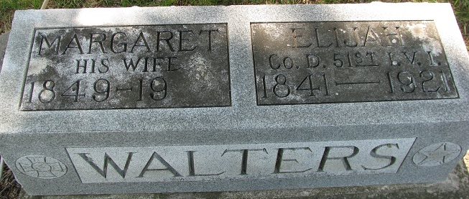
Photo by PLS

DEATH CLAIMS MRS. WALTERS
Mrs. Margaret Walters Dies at Home of Daughter Early Sunday

Mrs. Margaret A. Walters, 84, a resident of Decatur for a number of years, died at the home of her daughter, Mrs. Grace Moser, 115 South Seventh Street, Sunday morning at 4:15 o'clock. Death was due to paralysis. Mrs. Walters had been ailing for some time, but she became seriously ill last Saturday. She had resided in Decatur, making her home with her daughter, Mrs. Moser, for the last 12 years.
Mrs. Walters was born in Johnsonville, Ohio, March 24, 1849, a daughter of Samuel and Esther Teeple. She was married to Wilson S. Johnson on April 7, 1867 and six children, five girls and a boy were born to the union. Mr. Johnson and four girls are deceased. Her second marriage was to Elijah Walters on April 13, 1887. He preceded her in death on January 2, 1921. No children were born to this union.
Surviving are the son, and daughter: Joe Johnson of Wren, Ohio and Mrs. Grace Moser, Decatur. Two stepsons also survive, Homer Walters of Defiance, Ohio and Charles Walters of Cleveland, Ohio, together with eight grandchildren and several great grandchildren.
Mrs. Walters was a member of the local Methodist Episcopal Church and the Women's Relief Corps.
Funeral services will be held Tuesday afternoon at 2 o'clock at the Methodist Church and burial will be made in the Decatur Cemetery. The body was removed to the S. E. Black Funeral Home and will remain there until time for the funeral.

Decatur Daily Democrat, Adams County, Indiana
January 22, 1934

