Lulia Maude (Smith) Walters
March 20, 1876 – January 4, 1963

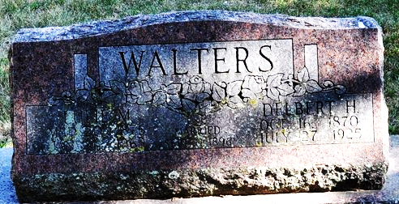
Photo by Deb Curry
Mrs. Lulie Walters Dies Friday Night

Mrs. Lulia M. Walters, 86-year-old Decatur lady, died at 9 o'clock Friday night at the Adams County Memorial Hospital following an illness of 90 days of complications. She was born in Adams County March 20, 1876, a daughter of Mr. and Mrs. Isaac Smith, and was a lifelong resident of the county. She was married in 1896 to Delbert H. Walters, who preceded her in death. Mrs. Walters was a member of the Calvary Evangelical United Brethren church.
Surviving are two daughters, Miss Margaret Walters and Mrs. Paul (Opal) Lillich, both of Decatur; two sons, Raymond Walters of Decatur, and Staff Sgt. John J. Walters, with the Marine Corps at Warrenton, Va.; 12 grandchildren and nine great-grandchildren. Four sons are deceased.
Funeral services will be conducted at 2 p.m. Monday at the Gillig & Doan funeral home, the Rev. W. R. Watson officiating. Burial will be in the Decatur Cemetery. Friends may call at the funeral home after 7 p.m. today until time of the services.

Decatur Daily Democrat, Adams County, Indiana
January, 5, 1963

