Louisa Jane (Shackley) Walters
May 13, 1845 – April 13, 1920

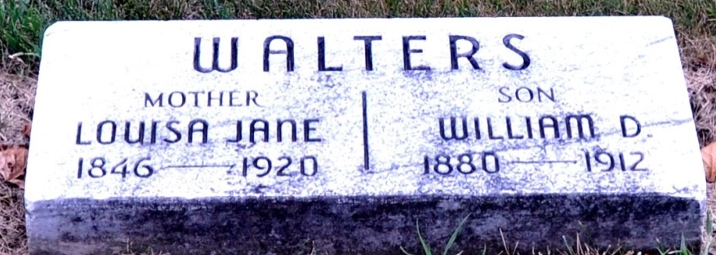
Photo by Deb Curry

DIED AT MARION
Mrs. Louisa Walters Died at the Home of Son at Marion Yesterday
LIFE LONG RESIDENT
Of This City - Went to Marion Few Weeks Ago - Funeral Thursday

J. F. Walters, traveling auditor of the Toledo, St. Louis and Western Railroad and a well-known Decatur young man, who has been checking up the details relative to transferring the local Clover Leaf Railroad agency over to the new agent, Sam Shamp, received a message yesterday afternoon informing him of the death of his mother, Mrs. Louisa Walters, a life-long resident of this city and who went to Marion, Indiana, just six weeks ago to visit with her son, Hiram Walters.
Mrs. Walters died Tuesday afternoon at the home of her son in Marion, death resulting from a long siege of dropsy and other complications brought about by infirmities of old age.
Mrs. Walters, who had been a life-long resident of this city, went to Marion six weeks ago to visit with her son, Hiram Walters. She had been in poor health for some time and recently took a turn for the worse, her condition becoming critical a week or so ago. She was born in Kennebunk, Maine, and had she lived until May 13th, this year, would have been seventy-five years old. She came to this city when a small child and has always made her home in Decatur, the family being reared in this city.
The body will be brought to this city probably Thursday afternoon over the Clover Leaf and burial will be made in the Decatur cemetery. It is planned to open the casket at the cemetery in order to give her many friends and relatives the opportunity to view her remains.
She is survived by the following children: Nelson Walters, of Anderson; J. F. Walters, of Marion, and Hiram Walters, also of Marion. Her husband preceded her in death about sixteen years ago.

Decatur Daily Democrat, Adams County, Indiana
Wednesday, April 13, 1920

**
Indiana, Death Certificates, 1899-2011
Name: Louisa Jane Walters
[Louisa Jane Shackley]
Gender: Female
Race: White
Age: 72
Marital status: Widowed
Birth Date: 13 May 1845
Birth Place: Maine
Death Date: 13 Apr 1920
Death Place: Marion, Grant, Indiana , USA
Father: Joseph Shackley
Mother: Louisa Emmons
Informant: Hiram Walters; Marion, Indiana
Burial: April 15, 1920; Decatur Cemetery

