Leona Elizabeth (Ward) Walters
January 23, 1903 – August 7, 1953

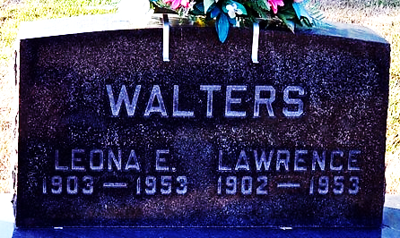
Photo by Deb Curry

Leora E. Walters
in the Michigan, Deaths and Burials Index, 1867-1995
Name: Leora E. Walters
[Leora E. Ward]
Birth Date: 23 Jan 1903
Birth Place: Adams Co., Indiana
Death Date: 7 Aug 1953
Death Place: Kalamazoo, Kalamazoo, Michigan
Burial Date: 10 Aug 1953
Burial Place: Decatur, Indiana
Cemetery Name: Decatur Cemetery
Death Age: 50
Occupation: Housewife
Race: White
Marital status: Married
Gender: Female
Residence: Pennville, Jay, Indiana
Father Name: James E. Ward
Mother Name: Susie Drum
Spouse Name: Lawrence
FHL Film Number: 2075143

