Lawrence Ranson Walters
April 5, 1902 – August 7, 1953

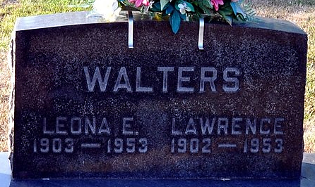
Photo by Deb Curry

Lawrence R. Walters
in the Michigan, Deaths and Burials Index, 1867-1995
Name: Lawrence R. Walters
Birth Date: 5 Apr 1902
Birth Place: Decatur, Ind.
Death Date: 7 Aug 1953
Death Place: Schoolcraft Twp., Kalamazoo, Michigan
Burial Date: 10 Aug 1953
Burial Place: Decatur, Indiana
Cemetery Name: Decatur Cemetery
Death Age: 51
Occupation: Glove Manufacturer
Race: White
Marital status: Married
Gender: Male
Residence: Penn Twp., Jay, Indiana
Father Name: Walters
Mother Name: Lulie
Spouse Name: Leona
FHL Film Number: 2075143

