John Virgil Walters
March 20, 1901 – July 19, 1971

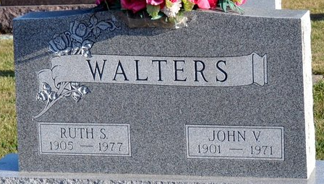
Photo by Deb Curry

John Virgil Walters
in the Indiana, Death Certificates, 1899-2011
Name: John Virgil Walters
Race: White
Age: 70
Marital status: Married
Birth Date: 20 Mar 1901
Birth Place: Indiana
Death Date: 19 Jul 1971
Death Place: Decatur, Adams, Indiana, USA
Father: Oliver Walters
Mother: Nellie Cramer
Spouse: Ruth S Martin
Informant: Mrs. Ruth Walters; wife; Decatur, Indiana
Burial: July 21, 1971; Decatur Cemetery; Decatur, Indiana

