John J. Walters
September 18, 1918 – September 7, 1990

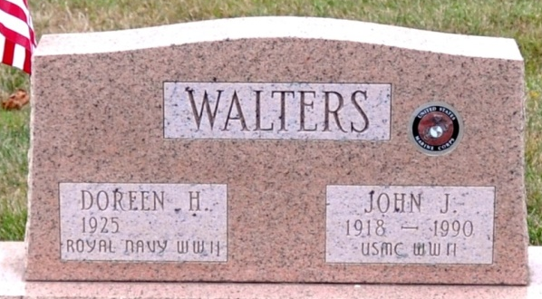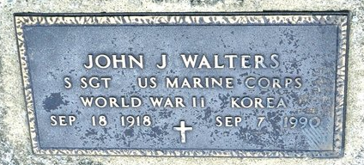
Photo by Deb Curry

John J. Walters, 71, 410 Line St., died at 4:15 p.m. Friday in the Department of Veterans' Affairs Hospital, Fort Wayne, after being in failing health for six weeks. He was born on September 18, 1918 in Bobo to Delbert and Lulie M. Smith Walters and married Doreen H. Thomason on February 23, 1950; she survives.
He was a highly decorated U.S. Marine Corps veteran of World War II, the Korean War, and other military engagements, such as the Marine landing in Lebanon in 1958 and the Bay of Pigs operation in Cuba in 1961. He served in the South Pacific in World War II and was among the survivors of the Chosin Reservoir escape during the Korean War after many U.S. troops were trapped by Chinese soldiers for a month in winter weather that hit 30 degrees below zero. He served in the Marines from 1940-63. After his military service, he was an aircraft mechanic at the Boeing Corp. plant in Seattle, Washington and with United Airlines in San Francisco, California. He was a graduate of Pleasant Mills High School and a former member of American Legion Post 43 and the Veterans of Foreign Wars.
Other survivors are a son, Alan T. Walters, a retired Marine Corps veteran in Jacksonville, Alabama; a daughter, Mrs. Timothy T. (Constance D.) Hammond, Route 5, Decatur; a sister, Opal L. Isch Lillich, 903 Winchester St.; two granddaughters and one grandson; and one step-grandson. A son, Bryan R. Walters, and five brothers are deceased.
At his request, there will be no funeral or visiting hours, but private, graveside services will be held at Decatur Cemetery. Preferred memorials are to the Korean War Memorial in Washington D.C. in care of Zwick-Sefton and Jahn Funeral Home.

Decatur Daily Democrat, Adams County, Indiana
September 8, 1990

