John Lloyd Walters
January 27, 1895 – April 27, 1968

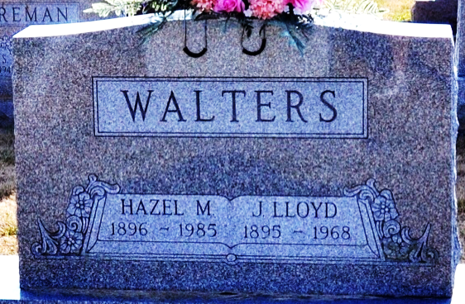
Photo by Deb Curry

John Loyd Walters
in the Indiana, Death Certificates, 1899-2011
Name: John Loyd Walters
Gender: Male
Race: White
Age: 72
Marital Status: Married
Birth Date: 27 Jan 1895
Birth Place: Ind
Death Date: 27 Apr 1968
Death Place: Decatur, Adams, Indiana, USA
Father: Jacob Walters
Mother: Nancy Koonley
Spouse: Hazel Fosnaugh
Burial: April 30, 1968 Decatur Cem.

