Inez L. (Rook) Walters
May 1, 1882 – February 24, 1945

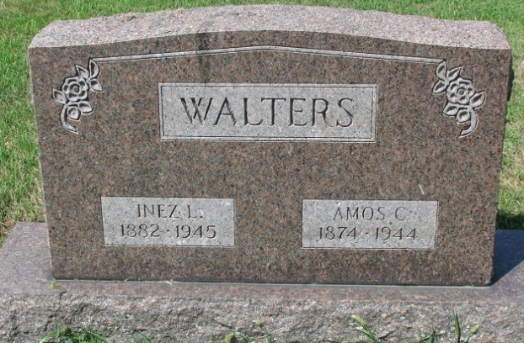
Photo by PLS
Inez L Walters
in the Indiana, Death Certificates, 1899-2011
Name: Inez L Walters
Gender: Male
Race: White
Age: 62
Marital Status: Widow
Birth Date: 1 May 1882
Birth Place: Adams Co, Ind
Death Date: 24 Feb 1945
Death Place: Ft Wayne, Allen, Indiana, USA
Father: Hyram Rook
Mother: Amanda Apple
Spouse: Amos Walters; died June 23, 1944
Informant: Miss Ardis Walters of Ft. Wayne, Ind.
Burial: Feb. 28, 1945, Decatur Cem., Decatur, Indiana

