Icie E. (Edwards) Walters
October 10, 1884 – December 7, 1955

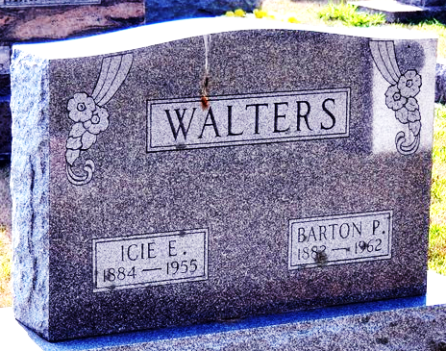
Photo by Deb Curry
Mrs Icie E Walters
in the Indiana, Death Certificates, 1899-2011
Name: Mrs Icie E Walters
[Mrs Icie E Edwards]
Gender: Female
Race: White
Age: 71
Marital Status: Married
Birth Date: 10 Oct 1884
Birth Place: West Virginia
Death Date: 7 Dec 1955
Death Place: Rural, Adams, Indiana, USA
Father: Joseph Edwards
Mother: Isabella Kemp
Informant: Barton Walters of Decatur, IN
Buried: Dec. 10, 1955 Decatur Cem., Decatur, Indiana

