Homer S. Walters
March 20, 1873 – October 6, 1963

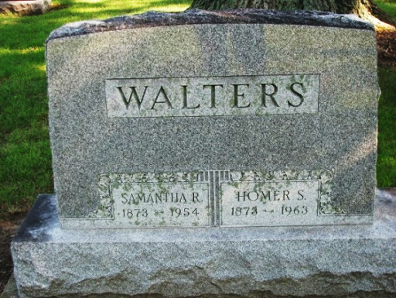
Photo by PLS

Homer Walter Dies at Defiance Hospital

Homer Walters, 90, native of Decatur and a retired farmer, died at 10:15 p.m. Sunday at City Hospital at Defiance, O. He formerly resided in Defiance, Route 6, but for the past two years had made his home with a niece near Continental, O. He was born in Decatur, March 20, 1873, a son of Elijah and Esther Hines-Walters, but moved from this city when a young man. His wife, the former Samantha Venus, preceded him in death Dec. 7, 1954.
Surviving are two sons, Donald and Bert Walters, both of Defiance route 6; two daughters, Mrs. Helen Bott of Defiance, Route 8, and Mrs. Edna Moore of Wyandotte, Mich.; a half-brother, Freeman Walters of Monroe, Route 1; 10 grandchildren and 26 great-grandchildren.
Funeral services will be held at 1 p.m. Wednesday at the Walker Funeral Home at Continental. The body will then be brought to the Decatur Cemetery for burial at 3:15 p.m. Wednesday, conducted by the Zwick Funeral Home. The body may be viewed before interment.

Decatur Daily Democrat, Adams County, Indiana
October 7, 1963

