Helene Emilie Anna (Berning) Walters
November 17, 1910 – November 4, 2004

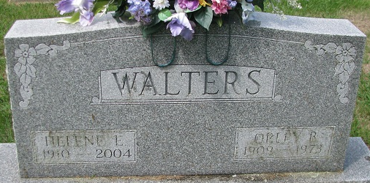
Photo by PLS

Helene Emilie Anna Walters
in the Indiana, Death Certificates, 1899-2011
Name: Helene Emilie Anna Walters
[Helene Emilie Anna Berning]
Gender: Female
Race: White
Age: 93
Marital status: Widowed
Birth Date: 17 Nov 1910
Birth Place: Decatur, In
Death Date: 4 Nov 2004
Death Place: Decatur, Adams, Indiana, USA
Father: Henry C Berning
Mother: Anna Bulmahn
Informant: Barbara Kohne; daughter; Decatur, Indiana
Burial: November 8, 2004; Decatur Cemetery; Decatur, Indiana

