Helen Walters
1945 -

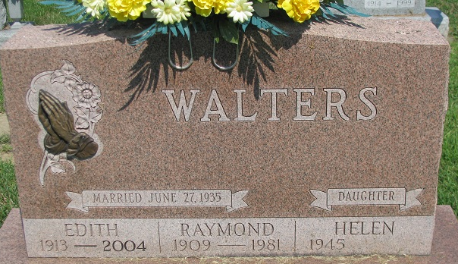
Photo by PLS

