Hazel M. (Fosnaugh) Walters
July 7, 1896 – October 15, 1985

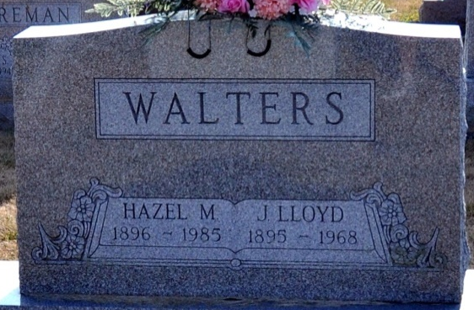
Photo by Deb Curry

Hazel M Walters
in the Indiana, Death Certificates, 1899-2011
Name: Hazel M Walters
[Hazel M Fosnaugh]
Gender: Female
Race: White
Age: 89
Marital Status: Widowed
Birth Date: 7 Jul 1896
Birth Place: Indiana
Death Date: 15 Oct 1985
Death Place: Decatur, Adams, Indiana, USA
Father: William Fosnaugh
Mother: Catherine Kesler
Informant: Richard Walters, son, of Albion, IN
Burial: Oct. 17, 1985; Decatur Cem.

