Grace E. (McConnehey) Walters
June 30, 1873 – April 30, 1950

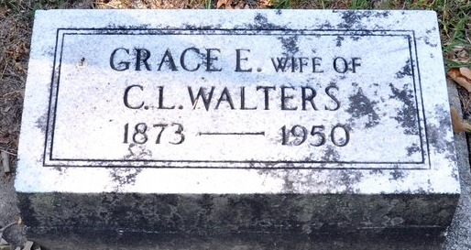
Photo by Deb Curry

Mrs. Grace Walters Dies Here Sunday
Prominent Decatur Lady Dies Suddenly

Mrs. Grace E. Walters, 76, widow of former Judge Clement L. Walters, and long prominent in church and social circles in this city, died at 10:25 o'clock Sunday morning at the Adams County Memorial Hospital of a heart attack. The attending physician pronounced the cause of death as angina pectoris. Seized with the attack, at her home, 104 South Fifth Street, Mrs. Walters was taken to the hospital at 9 o'clock. Apparently in good health, she had returned from Florida last Monday and was up town during the past week.
A former Decatur school teacher, Mrs. Walters also was for many years teacher of the Ever Ready Sunday school class of the First Methodist Church. A lay leader in her church, she was a member of the choir and the W. S. C. S. She was a member of the Eastern Star, the Pythian Sisters and was a past president of the W.C.T.U.
A daughter of John and Eliza J. Humes, Mrs. Walters was born in this city on June 30, 1873. She was graduated from Decatur High School and furthered her education with training for the teacher's profession. Mrs. Walters was married to Clement L. Walters, former attorney and jurist of this city, on January 5, 1896. His death occurred Oct. 25, 1939, shortly after he retired from the Circuit Court bench.
Surviving are three children, Robert Kenyon Walters of San Gabriel, Cal., Mrs. Helen Donovan of Fort Wayne and Mrs. Dorothy Leigh of Plymouth. One daughter is deceased. One grandchild, Jack Leigh, also survives.
Funeral services will be held Wednesday at 2 p.m. at the First Methodist Church, with Dr. Gerald H. Jones, pastor, officiating. Burial will be in the Decatur Cemetery. The body will be moved from the Zwick Funeral Home to the Walters' residence, where friends may call at 2 o'clock Tuesday afternoon.

Decatur Daily Democrat, Adams County, Indiana
May 1, 1950

**
Indiana, Death Certificates, 1899-2011
Name: Mrs Grace F Walter
Gender: Female
Race: White
Age: 76
Marital Status: Widowed
Birth Date: 30 Jun 1873
Birth Place: Indiana
Death Date: 30 Apr 1950
Death Place: Decatur, Adams, Indiana, USA
Father: John Mc Connehey
Mother: Eliza J Humes
Informant: Mrs. Helen Donovan, Ft. Wayne
Burial: May 3, 1950 Decatur Cem.

