Freeman Harrison Walters
April 21, 1878 – December 2, 1970

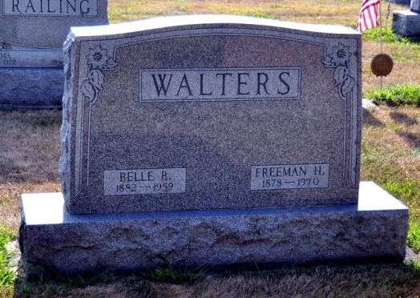
Photo by Deb Curry

Freeman H. Walters Dies this Morning

Freeman H. Walters, 92, of Monroe Route 1, a retired farmer, died at 3:30 a.m. today at the Adams County Memorial Hospital, where he had been a patient for five weeks. He had made his home with his children for the past six years.
He was born in Union Township April 21, 1878, a son of Henderson and Emily Harrison-Walters, and was married to Belle Barkley Dec. 22, 1907. His wife preceded him in death Feb. 26, 1959.
Mr. Walters was a longtime active member of the Monroe United Methodist Church, and a former trustee of the church.
Surviving are one son, Orley B. Walters of Decatur; four daughters, Mrs. Kenneth (Genevieve) Parrish, Mrs. Elmo (Naomi) Stuckey, Mrs. Wilson ( Anoli) Mann, and Mrs. Richard (Phyllis) Everett, all of Monroe; 21 grandchildren and 31 great-grandchildren. Three brothers, one sister, and a half-brother are deceased.
Funeral services will be conducted at 2 p.m. Friday at the Monroe United Methodist Church, with Rev. Donald Wilks and Rev. Vernon Riley officiating. Burial will be in the Decatur Cemetery. Friends may call at the Zwick Funeral Home after 7 p.m. today until 11:30 a.m. Friday, and from 12:30 p.m. at the church until time of the services.

Decatur Daily Democrat, Adams County, Indiana
Wednesday, December 2, 1970
**
Indiana, Death Certificates, 1899-2011
Name: Freeman H Walters
Gender: Male
Race: White
Age: 92
Marital status: Widowed
Birth Date: 21 Apr 1878
Birth Place: Indiana
Death Date: 2 Dec 1970
Death Place: Decatur, Adams, Indiana , USA
Father: Henderson Walters
Mother: Emily Harrison
Informant: Mrs. Kenneth Parrish; daughter; Monroe, Indiana
Burial: December 4, 1970; Decatur Cemetery; Decatur, Indiana

