Doreen H. (Thomason) Walters-Frecker
September 18, 1918 – September 7, 1990

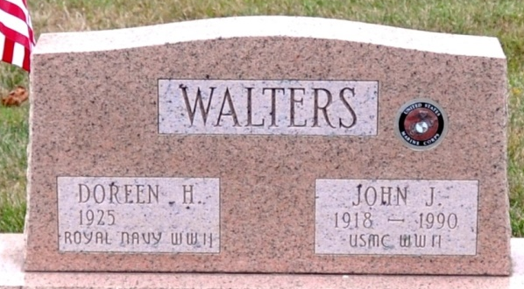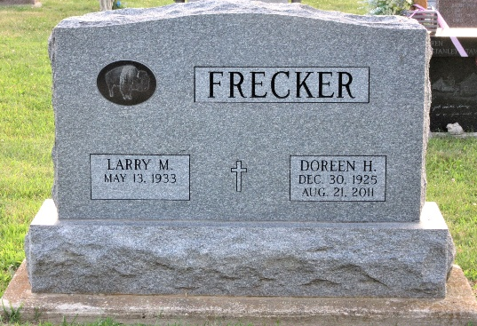
Photo by Deb Curry Photo by PLS

Note: Doreen has two stones, one in St. Joseph Catholic Cemetery in Adams County, Indiana with husband John J. Walters, the other in St. Joseph Catholic Cemetery in Allen County, Indiana with husband Larry M Frecker.

DOREEN H. WALTERS FRECKER, 85, of Decatur, passed away on Sunday, Aug. 21, 2011. Mass of Christian Burial is 11 a.m. Thursday, Aug. 25, 2011, at St. Joseph Catholic Church-Hessen Cassel. Visitation is from 4 to 8 p.m. Wednesday, Aug. 24, 2011, at Haggard-Sefton & Hirschy Funeral Home, with reciting of the Holy Rosary at 7:30 p.m.
Fort Wayne Newspapers, Allen County, Indiana
August 23, 2011
**

Indiana, Death Certificates, 1899-2011
Name: Doreen H Frecker
Maiden Name: Thomason
Gender: Female
Race: White
Age: 85
Marital status: Married
Birth Date: 30 Dec 1925
Birth Place: Manchester, EN
Death Date: 21 Aug 2011
Death Place: Ossian, Wells, Indiana, USA
Father: George Thomason
Mother: Annie Smith
Spouse: Larry M. Frecker
Informant: Larry Frecker; husband; Decatur, Ind.
Burial: St. Joseph Catholic Church Cemetery Hessen Cassel, Fort Wayne, Allen County, Ind.

