Forrest S. Walters
February 17, 1898 – March 26, 1972

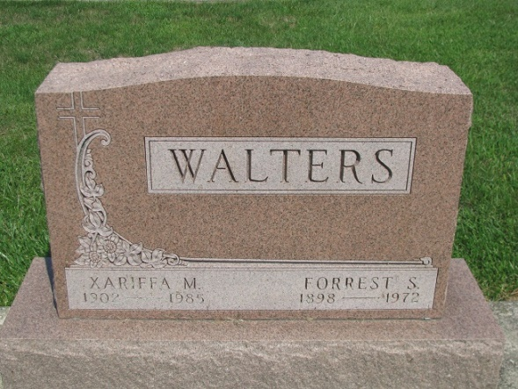
Photo by PLS

Forrest Walters Taken by Death

Forrest S. Walters, 74, of 703 North Second streets, died at 10:35 a.m. Sunday at the Adams County Memorial Hospital, where he had been a patient for four weeks.
He was a retired farmer and also an employee of Burk Elevator until 1946. He was born in Union Township Feb. 17, 1898, to Oliver C. and Nellie Cramer-Walters, and was married to Xariffa Barkley Sept. 27, 1924. Mr. Walters was a member of the Union Chapel United Methodist Church, and was treasurer of the Men’s Brotherhood of the church.
Surviving are his wife; one daughter, Mrs. Gerald (Marcella) Springer of Decatur route 3; one son, Leroy F. Walters of Decatur route 5; and seven grandchildren. A brother, John W. Walters, died July 19, 1971.
Funeral services will be conducted at 3:30 p.m. Tuesday at the Zwick Funeral Home, with Rev. Kenneth Swan officiating. Burial will be in the Decatur Cemetery. Friends may call at the funeral home after 2 p.m. today until time of the services.
Preferred memorials are to the Heart fund.

Decatur Daily Democrat, Adams County, Indiana
Monday, March 27, 1972

