Elijah J. Walters
March 20, 1841 – January 2, 1921

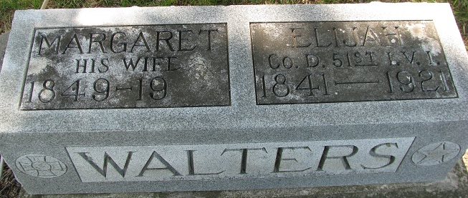
Photo by PLS

ELIJAH WALTERS DIED LAST NIGHT
Aged Civil War Veteran Passes Away After Long Illness from Paralysis Burial Wednesday
Had Lived in Adams County Seventy-five Years - Decatur

Twelve years suffering many months from paralysis and general debility, Elijah Walters, Civil War Veteran, and well known man, after making a brave fight against great odds, was compelled to surrender to the death angel Sunday evening at 8:05 o'clock, at the family home on First Street. Taking to his bed three years ago this coming February 2, Mr. Walters never was able to be about again, and although his suffering at times was intense, he was patient throughout, and realized for many months that the call of the Great Commander could be but a short time in the future.
Elijah Walters was born in Cumberland County, Pennsylvania, March 20, 1841, a son of Abraham and Elizabeth Walters, and is the last of the four children born to them. The family came to this county when the son was but five years old, and he had made his home here since, living many years in Union Township and for the past twelve years in the home on First Street, where his death occurred.
He was married three times, the first marriage being to Hester A. Hines, who died in 1879. To this union were born six children, three of whom are deceased, two sons dying in infancy and Mrs. Nora Debolt passing away twenty years ago. The other children are: Emery D. Walters of Decatur; Homer S., Defiance, Ohio; Mrs. Ida Miller of Convoy, O. The second marriage was to Emily J. Walters, her death occurring in 1881. One son, Charles M., now living in Cleveland, Ohio, was born to them, the mother passing away when he was but a few months old. The third union was with Maggie A Teeple, who survives, and who has been a constant companion and nurse during the months of his last illness. There are also five grandchildren, and two step-grandchildren, Grace Moser of Decatur, and Joe Johnson, Wren, Ohio. Had Mr. Walters lived until March 20, he would have been eighty years old.
The deceased was a member of the Grand Army of the Republic, and his comrades will have charge of the funeral service, arrangements for which had not been completed this afternoon pending word from relatives living at a distance. Late today it was announced the funeral would be held Wednesday afternoon, leaving the house at 1:30 o'clock, with services at the church at 2 o'clock, the Rev. Charles Tinkham officiating. Burial will be at the Decatur Cemetery.

Decatur Daily Democrat, Adams County, Indiana
January 3, 1921

**
Decatur, Ind., Jan. 3 – Elijah Walters, 80, veteran of the Civil War, and well known resident of Decatur, died Sunday night at 8:50 o'clock, following an illness of three years from paralysis and general debility. Mr. Walters was born in Cumberland County, Pa., and came here with his parents when he was five years old. He was married three times, the first wife dying in 1879, and the second in 1881. The third wife survives. Children who survive are Emery D. Walters, of Decatur; Homers S. Defiance, Ohio; Mrs. Ida Miller, Convoy, Ohio, and Charles M. Cleveland, Ohio. Funeral services will be held Wednesday afternoon, leaving the home at 1:30 o'clock for the Methodist church, where the services will be conducted by the Rev. Charles Tinkham. The members of the G. A. R., of which the deceased was long a member, will conduct ritualistic services.

Journal Gazette, Allen County, Indiana
January 4, 1921

